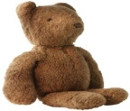
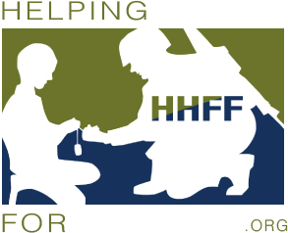
PLEASE HELP US MAKE CHRISTMAS SPECIAL FOR OUR MILITARY FAMILIES WITH CHILDREN. THEY MADE SACRIFICES TO PROTECT OUR FREEDOM, SOMETHING WE CAN NEVER REPAY, BUT YOU CAN SAY THANK YOU!
NOW IS YOUR CHANCE- LET'S GIVE THEM A CHRISTMAS THEY WILL NEVER FORGET!

PLEASE JOIN US FOR DINNER AND DANCING AT THE P4P (PATRIOTS FOR PATRIOTS) CHRISTMAS PARTY!
DON'T FORGET TO BRING A NEW TOY TO DONATE TO MILITARY FAMILIES IN NEED!
KNIGHTS OF COLUMBUS BANQUET HALL
4332 N GERMAN CHURCH RD. INDIANAPOLIS, IN
SATURDAY 12/5/15
7PM - MIDNIGHT
DRESS BUSINESS CASUAL – dress ready to party!

$5 DONATION, A SIDE-DISH AND A NEW TOY FOR ENTRY INTO THE PARTY!
PITCH -IN CONTEST! BEST SIDE DISH WINS CASH PRIZE!
DJ & KARAOKE- ROCK101
ADULTS ONLY- Everyone must be at least 21 years old to enter the party & must have a valid state issued ID.

BE READY TO WIN ITEMS IN THE SILENT AUCTION! LOTS OF GREAT PRIZES!
SILENT AUCTION:
WE WILL SELL TICKETS AT THE EVENT YOU DO NOT HAVE TO BE PRESENT TO WIN. YOU WILL HAVE A CHANCE TO WIN HOTEL STAYS, RESTAURANT GIFT CARDS, AND GIFT BASKETS OF ALL KINDS! SO BRING YOUR CASH AND BE READY TO GIVE BACK TO OUR MILITARY FAMILIES! IF YOU HAVE ITEMS YOU WOULD LIKE TO DONATE TO BE AUCTIONED, PLEASE CONTACT CATHLEEN MCGOVERN QUIGLEY 317-246-9925 OR CATHLEEN.QUIGLEY@HILTON.COM
OR CONTACT SEAN MCGOVERN AT 317-224-8253 OR SMCGOVERN@WATERSTONEMORTGAGE.COM

3 SPONSOR LEVELS:
GOLD: $500 DONATION - 25 ADMISSION TICKETS AND 100 RAFFLE TICKETS TO BID ON AUCTION/RAFFLE ITEMS. COMPANY NAME POSTED ON SOCIAL MEDIA AND NIGHT OF THE PARTY.
SILVER: $250 - 10 ADMISSION TICKETS AND 50 RAFFLE TICKETS TO BID ON AUCTION/RAFFLE ITEMS. COMPANY NAME POSTED ON SOCIAL MEDIA AND NIGHT OF THE PARTY.
BRONZE: $100 - 4 ADMISSION TICKETS AND 10 RAFFLE TICKETS TO BID ON AUCTION/RAFFLE ITEMS.

REMEMBER YOUR DONATIONS ARE A TAX WRITE OFF- NON-FOR-PROFIT - KNIGHTS OF COLUMBUS
TAX ID NUMBER _______________________________
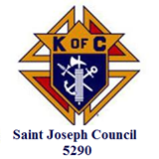
Acceptable Toys: puzzles, books, card games, board games, footballs, basket balls, soccer balls, arts/crafts, dolls, cars trucks, DVD movies or toy themes- dora the explorer, Frozen, minions, star wars, dinosaurs- Jurassic park.

A BIG SHOUT OUT TO THE SPONSORS AND VOLUNTEERS! THANK YOU!
